**Assignment 2**

**Supermarket Sales Analysis (Jan–Mar 2019)**

**1. Donut Chart**

* **Use Case**: Show distribution of sales by *Payment Method* or *Customer Type*.

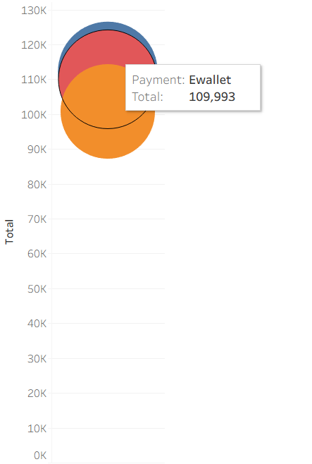

**2. Area Chart**

* **Use Case**: Show trend of Total Sales over time.

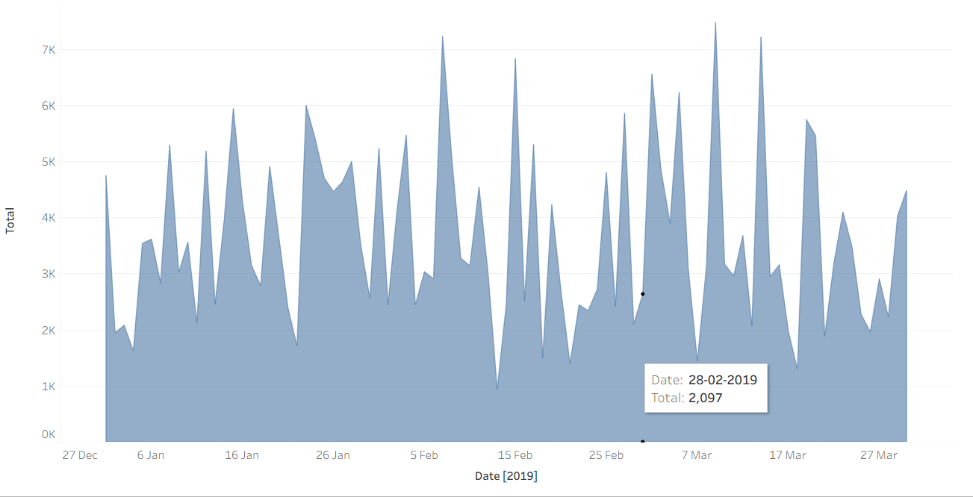

**3. Text Table**

* **Use Case**: Display detailed values like *Branch-wise sales*.

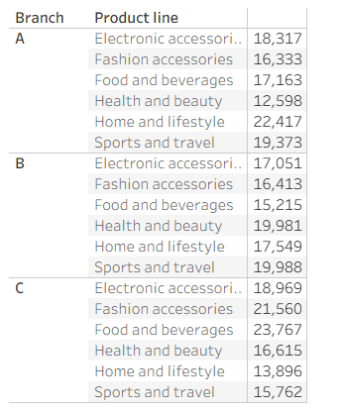

**4. Highlighted Table**

* **Use Case**: Visual emphasis on high or low values (e.g., *Rating by City*).

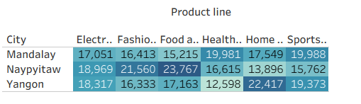

**5. WordCloud**

* **Use Case**: Visual frequency of product lines or customer types.

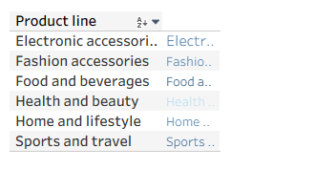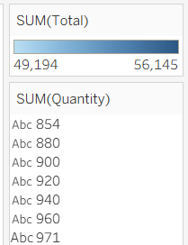

**6. Funnel Chart**

* **Use Case**: Show customer movement or sales quantity by stage (e.g., by Product Line).

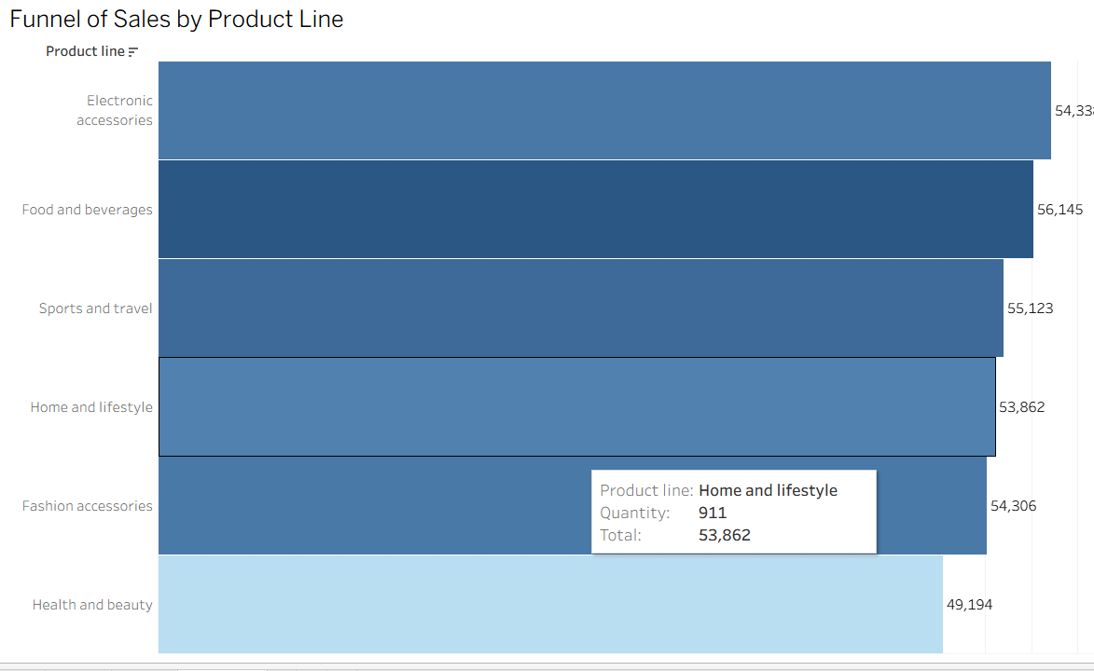

**7. Waterfall Chart**

* **Use Case: Show cumulative effect of sales over time or per branch.**

